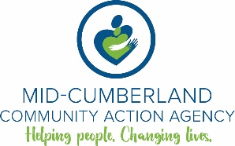
Mid-Cumberland Community Action Agency
Position Description

Board Chair
MISSION STATEMENT:

Mid-Cumberland Community Action Agency is committed to empowering people and communities toward economic independence.

RESPONSIBLE FOR:

The board chair or board president oversees the work of the board, the senior management team and the organization. In addition, the board chair should have a good working relationship with the executive director.

SPECIFIC DUITES OF THE JOB:

- Identifying the needs of the community
- Establishing the Agency Mission Statement including long- and short-range goals of the Agency and evaluating progress in meeting them
- Formulating strategic plans for Community Action, Inc.
- Approving overall plans and priorities
- The board chair oversees the work of the board, the senior management team and the organization.
- Appoint all committee chairs and to recommend committee members as appropriate.
- In other duties, the board chair works closely with the executive director to prepare board meeting agendas for board meetings. In addition, board chairs play a major role in conducting new board member orientation sessions.
- Coordinating an annual performance review of the executive director. It’s considered best practices for nonprofit boards to do annual self-evaluations. Board chairs assist in helping board directors assess their own performance.
- As lead board director and meeting facilitator, board chairs also work closely with governance committees on recruiting board members.
- Serve as an alternate spokesperson for the organization.

