PUBLIC MEDIA RELEASE 2026-2027
CHILD AND ADULT CARE FOOD PROGRAM

Date: 10/9/2026

Sponsor Name: Mid Cumberland Community Action Agency announces participation in the Child and Adult Care Food Program. Meals will be provided at no separate charge to eligible children/adults enrolled in the program without regard to race, color, national origin, sex, disability, age, or reprisal or retaliation for prior civil rights activity in any program or activity conducted or funded by USDA served at the following site(s):

Name of Site(s) Address of Site(s)
Ashland City HS/EHS | 104B Elizabeth Street  Ashland City, TN 37015
Bransford Head Start | 700 Bransford Drive  Springfield, TN 37172
Cedarwood Head Start | 103 Cedarwood Drive  Lebanon, TN 37087
Dickson Head Start | 119 W Broad Street  Dickson, TN 37055
Houston Head Start | 3215 TN 149  Erin, TN 37087
Humphreys Head Start | 205 S Clydeton Road  Waverly, TN 37185
Gallatin 1 Head Start | 242 W Eastland Street  Gallatin, TN 37066
Gallatin 2 Head Start | 625 Hartsville Pike  Gallatin, TN 37066
Hartsville EHS | 301 College Street  Hartsville, TN 37074
Murfreesboro Head Start | 219 S Maney Avenue  Murfreesboro, TN 37130
Rose Hill Early Head Start | 807 Rosehill Circle  Springfield, TN 37172
Shalom Zone Head Start | 600 Small Street  Gallatin, TN 37066
Big Rock Head Start | 500 Williams Road  Big Rock, TN 37023
Woodbury Head Start | 630 W Lehman Street  Woodbury, TN 37190
MCCAA ELC @ First Baptist Winchester Street | 290 E. Winchester Street  Gallatin, TN 37066
MCCAA ELC @ Hull Circle | 445 Hull Circle  Gallatin, TN 37066

USDA Income Eligibility Guidelines Effective July 1, 2026, through June 30, 2027

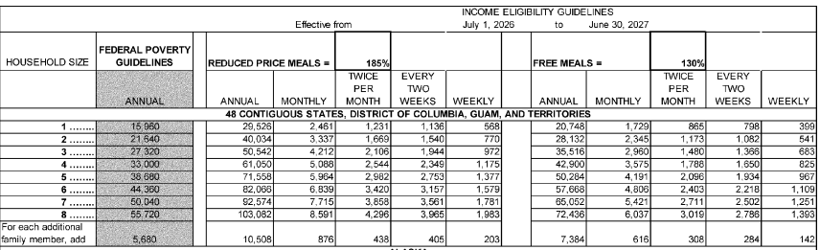
In accordance with Federal civil rights law and U.S. Department of Agriculture (USDA) civil rights regulations and policies, the USDA, its Agencies, offices, and employees, and institutions participating in or administering USDA programs are prohibited from discriminating based on race, color, national origin, sex, disability, age, or reprisal or retaliation for prior civil rights activity in any program or activity conducted or funded by USDA.

Persons with disabilities who require alternative means of communication for program information (e.g. Braille, large print, audiotape, American Sign Language, etc.), should contact the Agency (State or local) where they applied for benefits. Individuals who are deaf, hard of hearing or have speech disabilities may contact USDA through the Federal Relay Service at (800) 877-8339. Additionally, program information may be made available in languages other than English.

To file a program complaint of discrimination, complete the USDA Program Discrimination Complaint Form, (AD-3027) found online at: http://www.ascr.usda.gov/complaint_filing_cust.html, and at any USDA office, or write a letter addressed to USDA and provide in the letter all of the information requested in the form. To request a copy of the complaint form, call (866) 632-9992. Submit your completed form or letter to USDA by:

(1) mail: U.S. Department of Agriculture, Office of the Assistant Secretary for Civil Rights, 1400 Independence Avenue, SW, Washington, D.C. 20250-9410;

(2) fax: (202) 690-7442; or

(3) email: program.intake@usda.gov.

This institution is an equal opportunity provider.

